Register or update your child for services at your school’s health clinic.

School Wellness Program Consent Form:
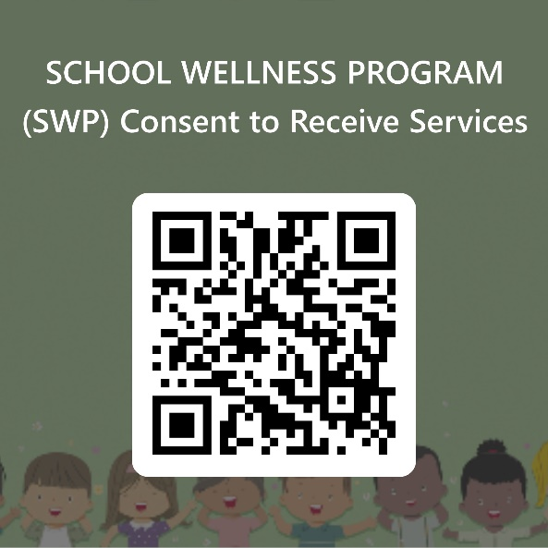
https://forms.office.com/g/UTRuHqdcsD

School Wellness Program Student Health Information
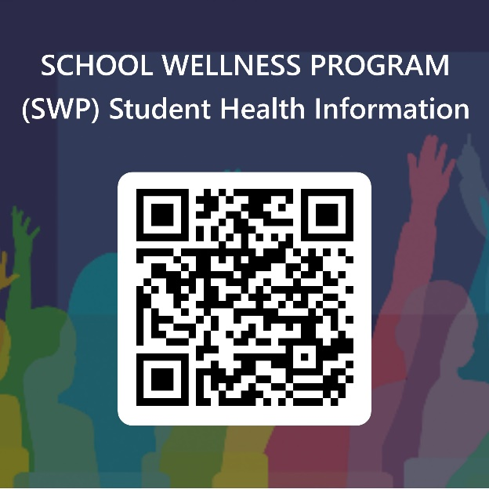

https://forms.office.com/g/rYda87iB5Y

